|  |  |  |
| --- | --- | --- |
| For The University of Nebraska-Helikar Lab | GSOC PROPOSAL  2015 | |
| This proposal is based on my understanding of your project and provides the details of how and why would I like to contribute towards the welfare of this project. All the information provided in the proposal is correct to the best of my knowledge and the work is my sole effort. | |  |

Efforts by Soumitra Agarwal

Guwahati,Assam,India

Phone:+917896878233

Email: a.soumitra@iitg.ernet.in, agarwalsoumitra1504@gmail.com

GitHub:SoumitraAgarwal@github.com

Education

# Indian Institute of Technology, Guwahati Pursuing presently

Bachelor of Technology with Honors in Mathematics and Computing 2014-2018

India International School, Jaipur Percentage: 94.3%

12th Grade Examination under Central Board of Secondary Education 2005-2014

Research Interests

Web Development, Algorithms, Machine Learning, Scientific Computing

Previous Works/Interests

*Biotechnology and bioinformatics:*

* Worked on a research based project on biological pollution indicators under the SCIPE module of IAPT(Indian association of physics teachers), and was ranked 1st among 10,000 individuals
* Currently pursuing a course on biotechnology at IIT Guwahati under professor Arun Goyal.
* Did a 3 year major course on biotechnology at High School
* Created a working model on animal anatomy at The Central Board of Secondary Education Science Fair

*Programming and others:*

* Worked on a driver control Machine Learning project on Kaggle. *Fall*  2014

*Under MS Student: Mr.Pranav Jindal, Stanford, USA*

* Created an application for developing games using simple user *Spring*2014

interface at the Microsoft Hackathon.

* Created a web-based application to improve *Fall* 2014

social interaction at the IITG Alcheringa Model United Nations

# Technical Skill Set

Programming/Scripting Skills C++, Java, Python, MATLAB, Octave, C#

Databases MySQL

Others HTML5, CSS3, JavaScript(including WebGL, Three.js), Git, Ruby(Rails)

*Started contributing for open source software in winter 2014, and has been continuing ever since. Has contributed to societies like SciRuby ,Rails, ROS and Mozilla.*

The Project

#### In lieu of the idea by "The Helikar Labs- University of Nebraska":

#### Interactive, Real-Time Dynamics Visualization Of Complex Network Graphs.

*\*Guide to timeline: Green represents time required for given process, Red represents time gone, Blue represents time left. Assuming 40 hours per week.\**

I usually run my code in Chrome. The reason is that, most often, Chrome has the best support and performance for WebGL /other renderers and it has a really great JavaScript debugger. With this debugger you can quickly pinpoint problems, for instance, by using breakpoints and console output. Suggestions to edits/additions to the idea are as follows:

1.Making a 3-D model with features:

This would be done using the most simple features from the library three.js and using some of the common renderers. The network will be a 3-dimensional structure with interconnected network points as stated in the original idea .This would be the foundation of what we want to do.

* Easy addition and removal of nodes:

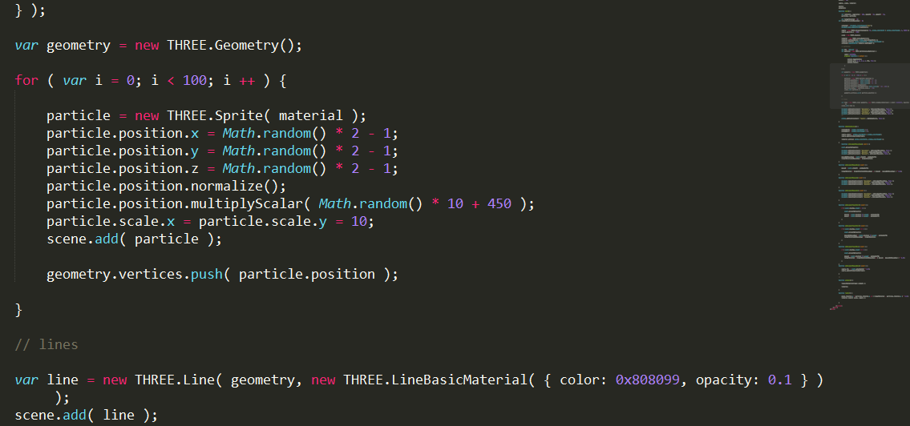The given image shows how we may add a small number of particles to create a simple network of given data

points .I will use the Geometry object from the Three.js library to store set of coordinates all points and using it later to create connections between several nodes.

* Shifting of nodes, providing feedback on the change in data on changing the position of this node.

I will enable shifting of nodes of a by deleting the previous particle from the geometry object and creating a new particle in its place and recreating the line geometry.

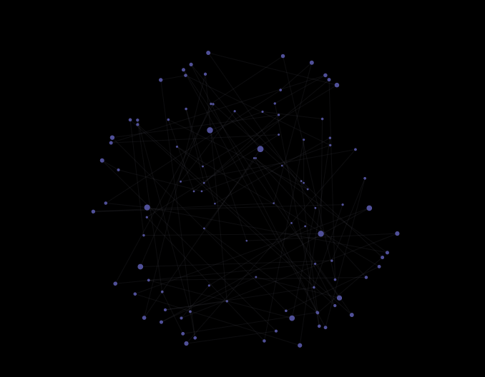

The expected foundation of our project is thus made, and now we can begin making changes to it. The expected network must be comparable to something like the one given beside.

And here we begin the real work.

2.Zooming the plot:

* Scroll zooming:

*Why this?*

Scroll zooming is one of the most common ways that are generally used to zoom graphics. Users tend to expect the illustration to zoom in once they scroll up and when it doesn't happen it gives them the feeling that something is missing. Thus it is utmost essential to include this feature.

*How would I incorporate it?*

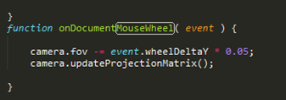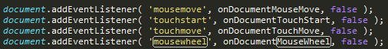Simple scroll zooming can be performed by using the events handler in JavaScript and render it with camera.fov or camera field of view method from the three.js library.

*What would actually happen?*

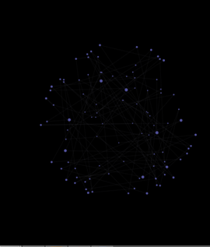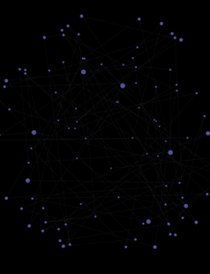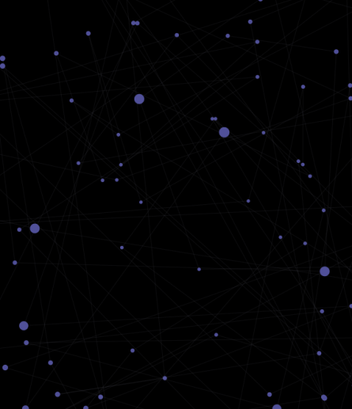

The above shown series of screenshots one after another show what we expect from our illustration. These were taken while continuously scrolling up on the mouse wheel. As this uses no binding of keys, it supports all touchpads with 2 finger scroll enabled.

* Zooming allows free movement:

Movement is allowed while zooming. As in no binding of mouse keys with scroll keys.

*Why this?*

This allows quick approach to the point/node concerned by simultaneously moving towards the point with zoom and movement.

*How would I incorporate it?*

By assigning zooming and movement to different event lists, like zooming may be assigned to 'onDocumentMouseWheel' whereas movement can be assigned to something like 'onDocumentMouseMove' as shown in the code.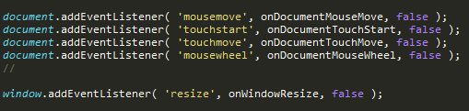

*What would actually happen?*

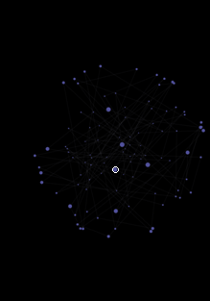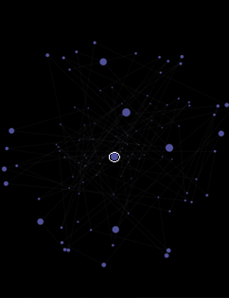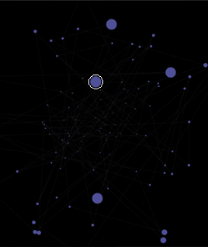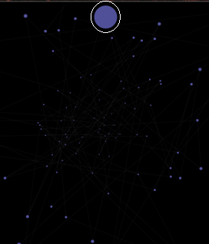

The point in the white circle depicts the expected movement of a specific particle when it is zoomed using scroll and moved using the mouse buttons.

* Variable approach points of zoom:

Change the location of where you want to go when you are zooming.

*Why this?*

This allowed detailed analysis of each and every node/ areas easier as generally we need two use 2 unbound motions of lateral movement and zooming, whereas by setting the approach point, one may directly zoom to the destination. It provides a more systematic way of studying graphs/projections of large amount of data.

*How would I incorporate it?*

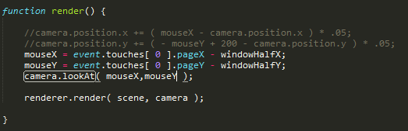

As given above, I will use the 'camera.lookAt' function while rendering the scene, and assign the value of x and y coordinates as the coordinates where mouse touched the page. Since the camera is fixed to look at that point it scroll zoom will take it only to that point.

*What will actually happen?*

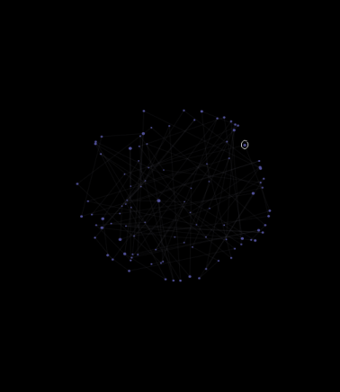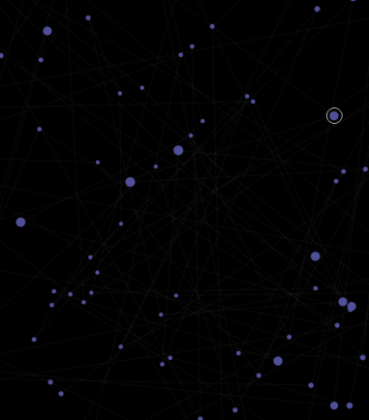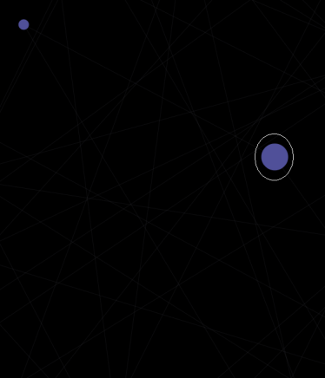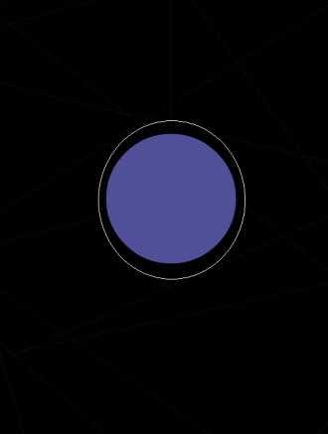

The approach zoom enables the particle to eventually come at the centre of the screen. This might help us in easy tracking, marking/unmarking (which will come on later) and study of nodes.

Hurdles?

Presently my thinking allows to achieve this expansion, but the whole geometry rotates (collection of particles).What I wanted to achieve was to fix the geometry while using this approach, and I would try and overcome this situation.

3.Interactive rotation/panning of the plot:

*\*As it was difficult to explain the pan using screenshots of networks, I used a cube instead for all panning examples.\**

Most of the ideas here are inspired from Google Earths panning options. It gives an realistic experience and also makes one feel that he is in control of the things.

* Free movement:

Move in any direction/Pan in any combination of coordinates.

*Why this?*

Why not? It creates an ease over the control and opens up so many different streams where one may take this and sometimes it is absolutely

necessary.

*How would I do it?*

*For a normal pan one may use the plane to pan right and left according to the mouse movement, as:*

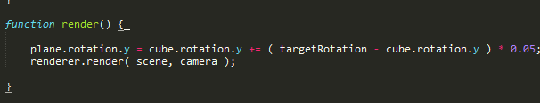

For the special pan ,as I like to call it, one may do it by recursively rendering the camera positions, as:

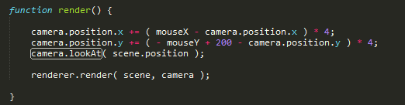

What this does is actually pans it in simple ways along both axis, but what is more beautiful is the way it is different from every other pan, is the cinematic feel of the pan.

*What would actually happen?*

Normal Pan:

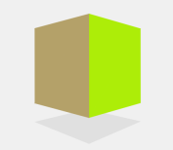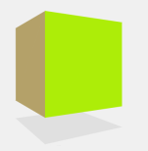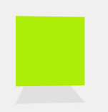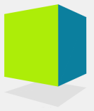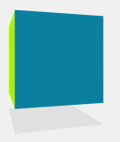

This example of pan is shown along one axis only. Distance of cube from camera remains constant throughout.

The Special Pan:

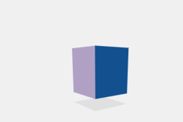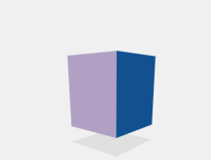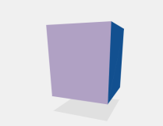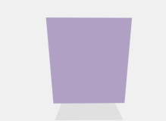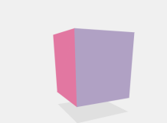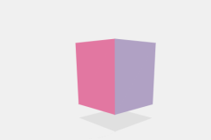

This example of pan is shown along one axis only. Distance of camera from cube decreases and then increases again. Gives cinematic feel.

*Hurdles?*

Creating this for one axis is a difficult task in itself for a huge amount of data, and then along all axis makes it difficult to render. Thus I need to think of a better way to pan it along multiple and possibly all axis in the special manner.

* Continuation of movement after the cursor stops .

*Why this?*

Gives a realistic feeling of how a graph must move when a cursor urges it to rotate, the same way Google Earth does. This is what is expected to happen.

*How would I do it?*

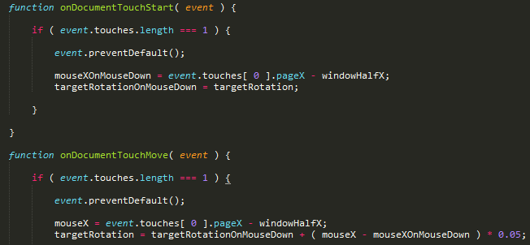

Using the targetRotation variable with the targetRotationOnMouseDown allows us to use the time gap between the present and the time the cursor stopped. I extended the motion of the cube by multiplying it by a reducing factor of 0.05.Thus every time this function steps up, velocity decreases by a factor of 0.05 as show above.

What will actually happen?

After we have once pushed the cube to move, even if we stop the cursor the cube

continues its motion until friction takes over(The factor 0.05)

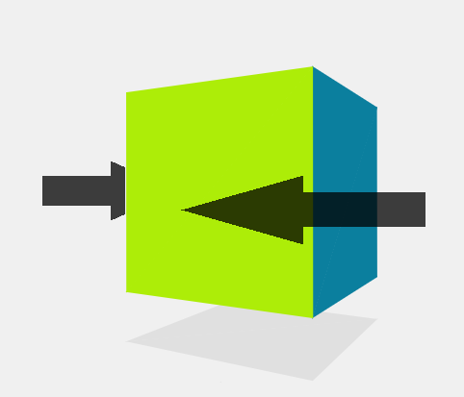

4.Sectioning of the plot to provide better view of inner points:

* Sectioning through axis

*Why this?*

Data analysis and visualisation is always easier when the amount of data is small. To analyse large amount of data one may divide large data into smaller bits and analyse required piece independently. This analysis. This 'Divide and Conquer' process is generally used by us, developers to tackle difficult problems.

*How would I do it?*

*Using Boolean operations with a library like 'Constructive Solid Geometry' and do a mesh subtraction. Other manipulations can be performed by using algorithms to slice a mesh etc.*

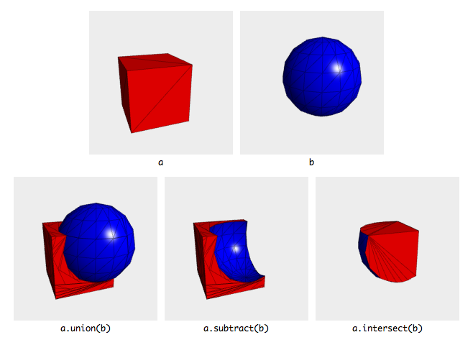

*\*image source* [*http://github.com/evanw/csg.js/*](http://github.com/evanw/csg.js/)

This would require a lot of time and effort as this is something I haven't done in the past but looks like a good idea to work on.

5.Colour gradient/Shadows:

*WHY THIS?*

Provides better sense of depth , and when used with sectioning the degree of precision is improved.

*HOW WOULD I DO IT?*

To set the colour gradient, one may use simple code to

evaluate the distance of the point from origin and replace the RBG values of the MaterialColour as a function of it.

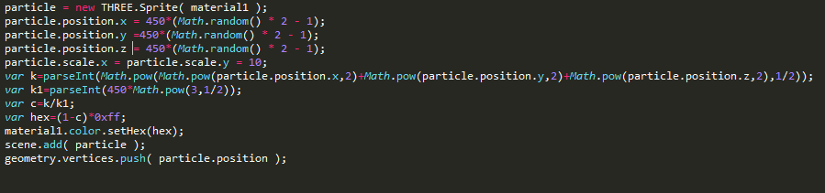

Something like the code given above utilises the fact that we know the upper bound for the distance is known. In cases where it is not known, a simple Max function does the job. Whereas shadows can be induced using the Lambert material and spotlights.

*WHAT WOULD IT LOOK LIKE?*

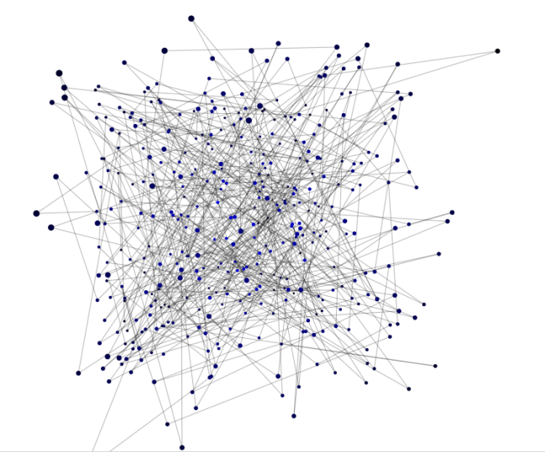In such a haphazard network with so many points, it becomes extremely tough to analyse their positions when zoomed in. Thus our colour gradient method allows us to catch hold of particles that are inner and outer very easily. On zooming in:

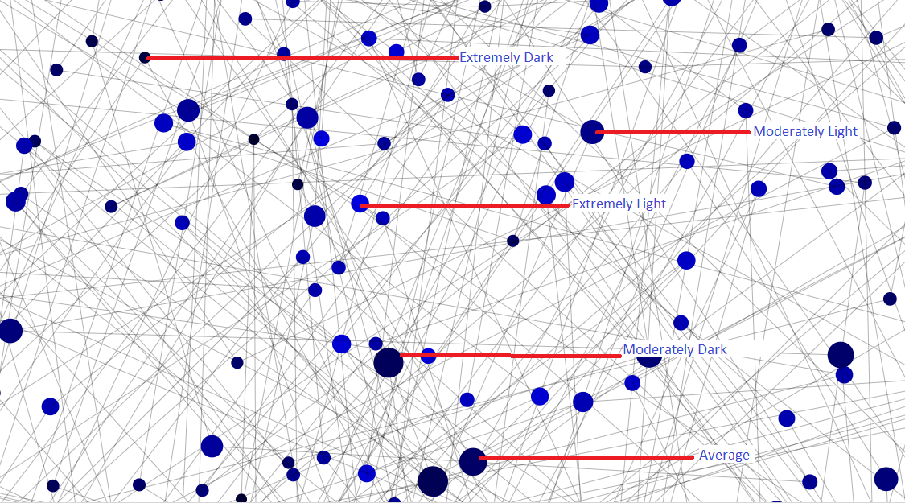

The figure above clearly shows how our analysis has been eased, by the use of colour gradients.

6.Real time change of pattern:

* Pattern change:
* Hierarchical
* Grid
* Hair Network
* Point Cloud
* Colour change:
* Negative
* Colour scheme

*WHY THIS?*

Sometimes we encounter data where one type representation is not enough to depict the data totally. More and more representations lead to more and more superiority in the level of understanding.

*HOW WOULD THIS HAPPEN?*

Let us take this one by one. First of all, we change the types real time. To do this we use the library created by some guys at Google, called the dat.GUI which allows you to very easily create a simple user interface component that can change the variables in your code.

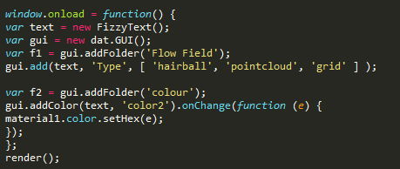

*WHAT WOULD ACTUALLY HAPPEN?*

*Different types of graphs and colours change real-time, and it looks something like the one given below.*

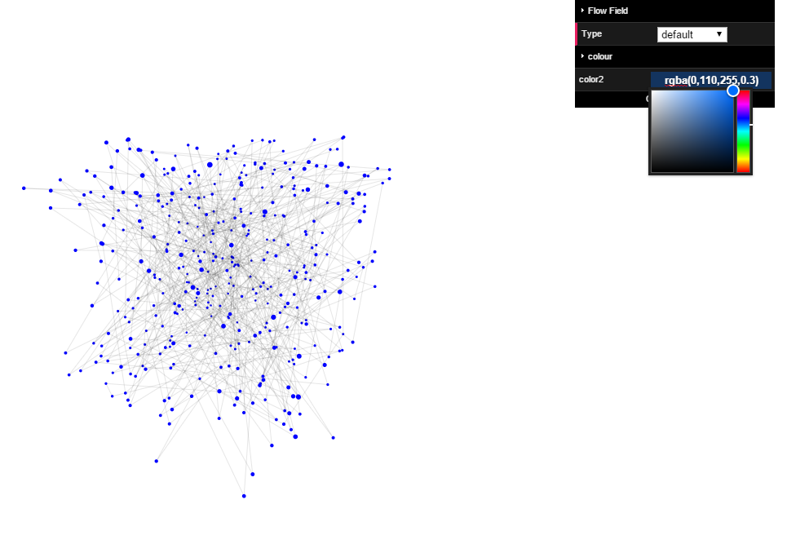

This is what it looks like in default colours. Now we change the colours using the tools available to us.

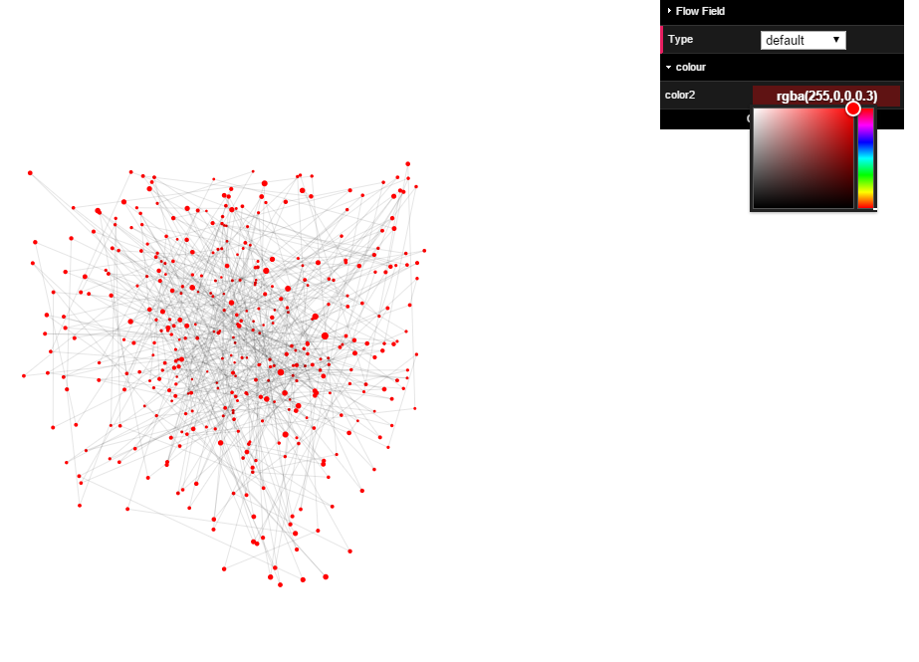

Similarly we might change the type of graphs, and though I wanted to work on more representations, presently these are the only one I could incorporate.

Different kinds of pattern that change on the click:

1.Negative:

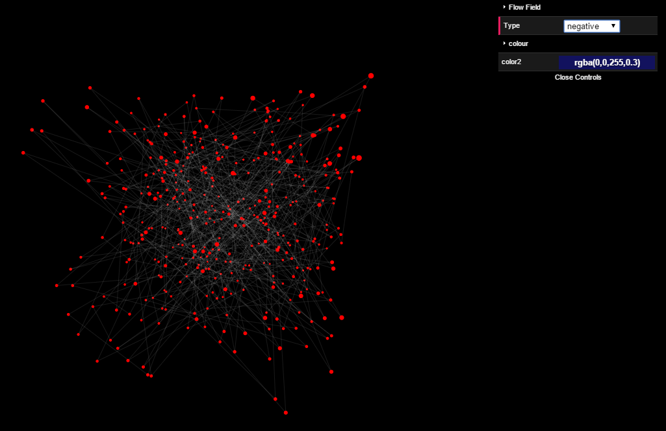

2.Hair network: 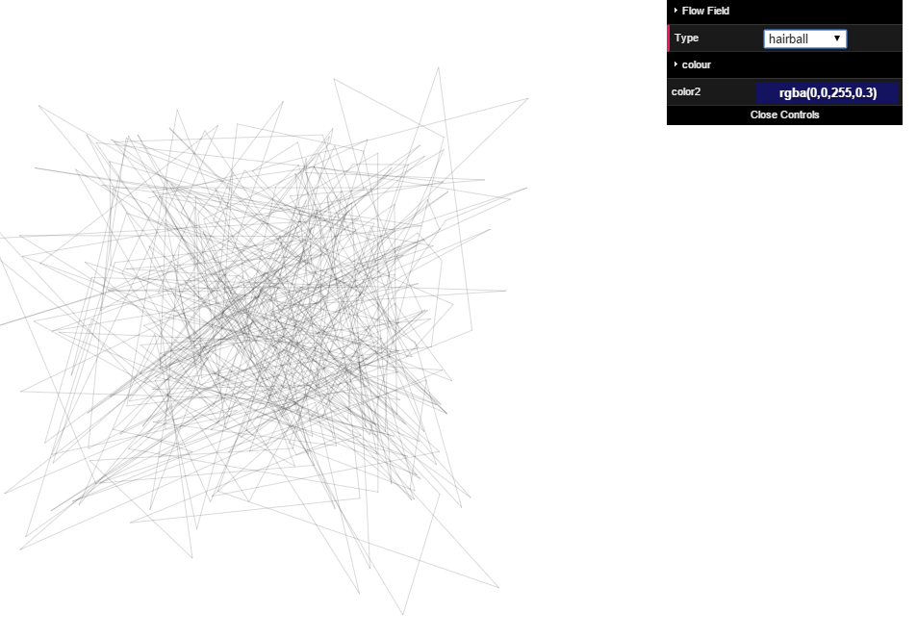

3.Point cloud:

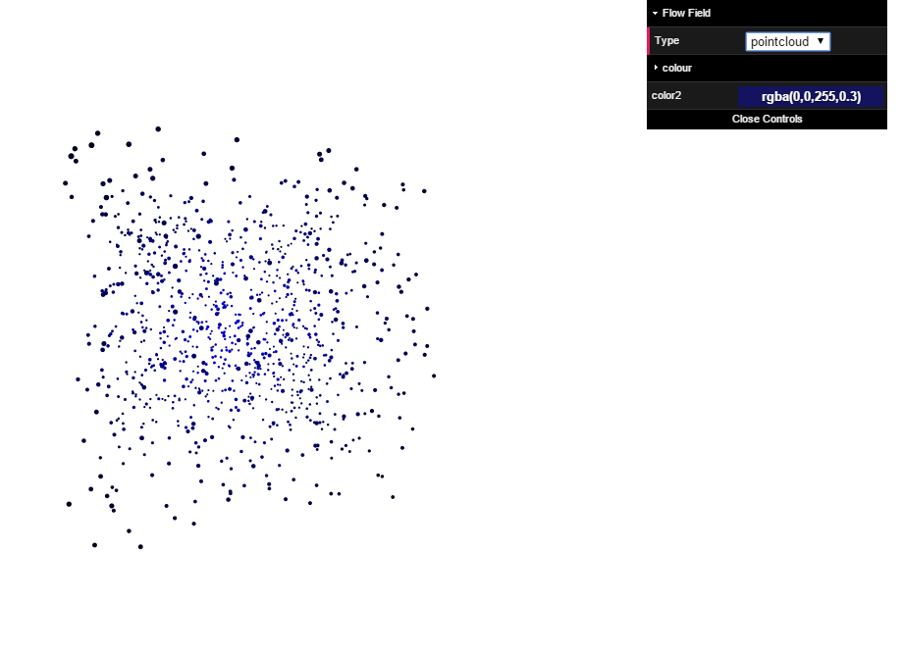4.Grid:

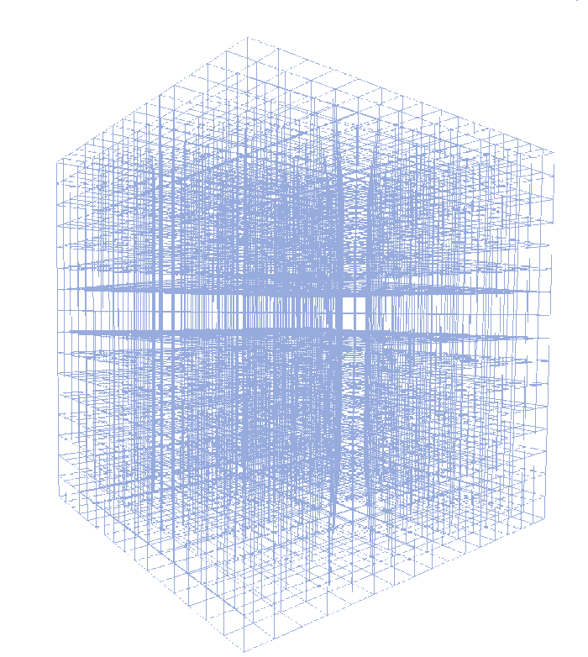

It is expected to look something like this (with nodes as colour points).

7.Real time changing of data

*WHY THIS?*

We are all humans and making errors one a data that is huge is normal. Therefore for the last minute edits or addition/subtraction of nodes in general must be essential feature of our representation.

*HOW WOULD I DO IT?*

Similar to the above examples, we will use the dat.GUI library , and give the freedom of adding it to the user.

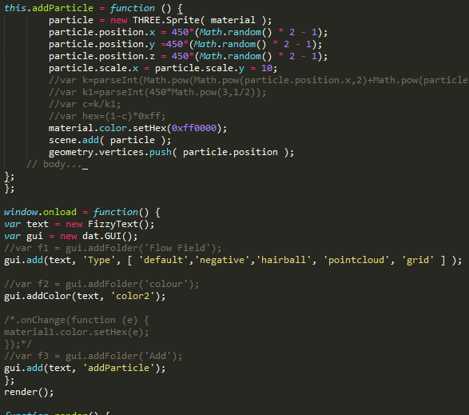

Thus each time on the click event of the control add particle, a new particle is added(at a random position for the time being) but doesn't add the set of edges associated with it. I would work upon this and adding of edges in the deadline set.

Similarly particles can be removed using a similar algorithm.

*WHAT WOULD ACTUALLY HAPPEN?*

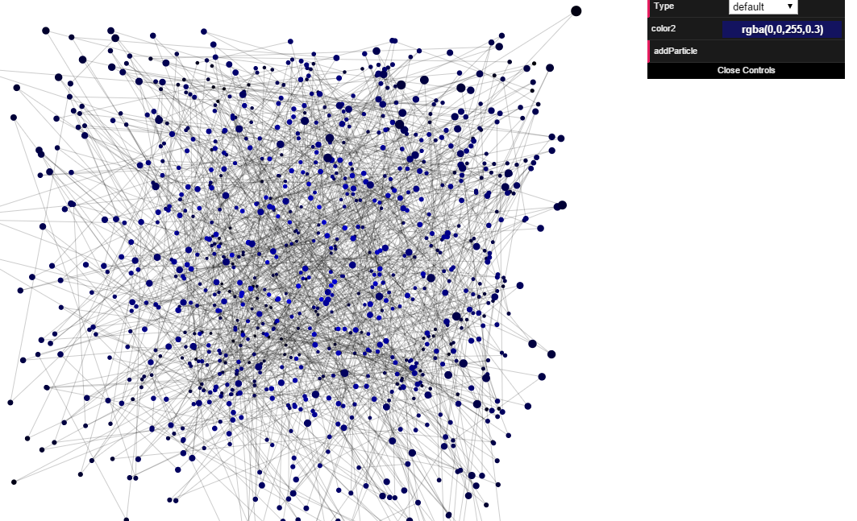

On click event of add particle control, a new red particle is introduced on the stage.

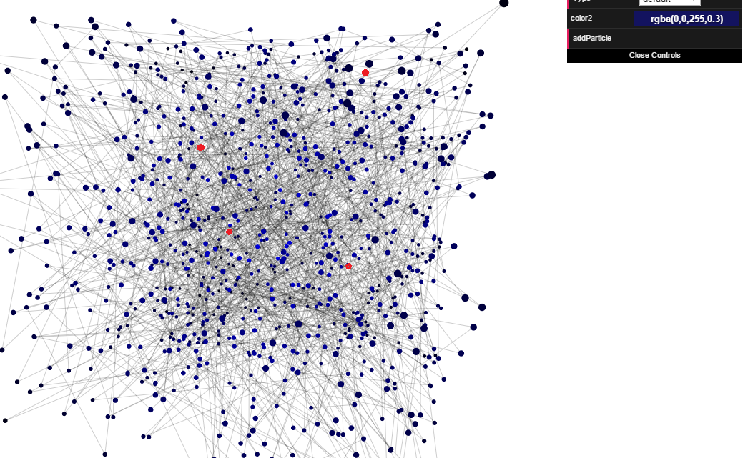

Addition of specific particles (with specified x,y and z coordinates) will be incorporated as the time progresses.

8.Interactivity

* Hover and Click event handling.
* Closest node of approach.

*WHY THESE?*

Mouse interaction is usually part of the trivia where developers generally want to excel. Hovering and Click interaction provides us with many options to interact with the user and opens up many ideas.

*HOW WOULD I DO IT?*

* *Hover and click even handling.*

Java Script provides us with amazing interface options like intersect etc. which we can use to detect the intersection of mouse and a particle/ edge. While click events are part of the day to day use. What I propose is, there be temporary colouration on hover and permanent on click.

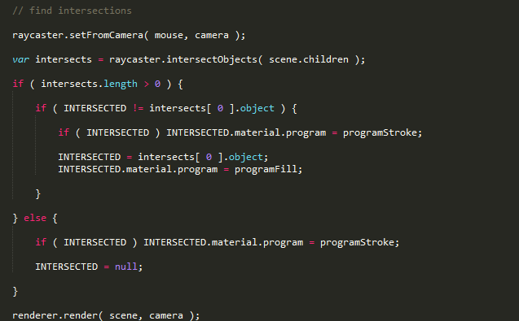

* Closest node of approach.

This is an interesting one. What most people think that the quad Tree approach towards finding the closest particle would be better, I suggest a completely different algorithm. I suggest creating a sphere of radius equal to the distance of the point from origin. Then, just like binary search, we keep on seeking the mid points of surface of different spheres, until we get 2 lines of intersection. This would be much more efficient than the quad Tree approach for randomly arranged particles.

*WHAT WOULD ACUALLY HAPPEN?*

*Hover and click even handling.* 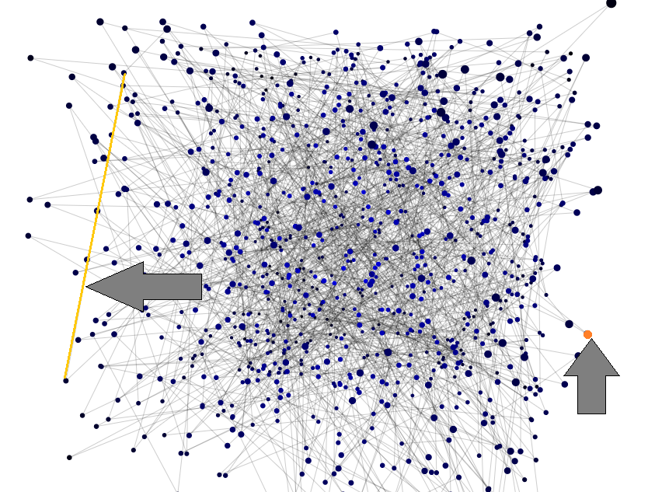

* Closest node of approach.

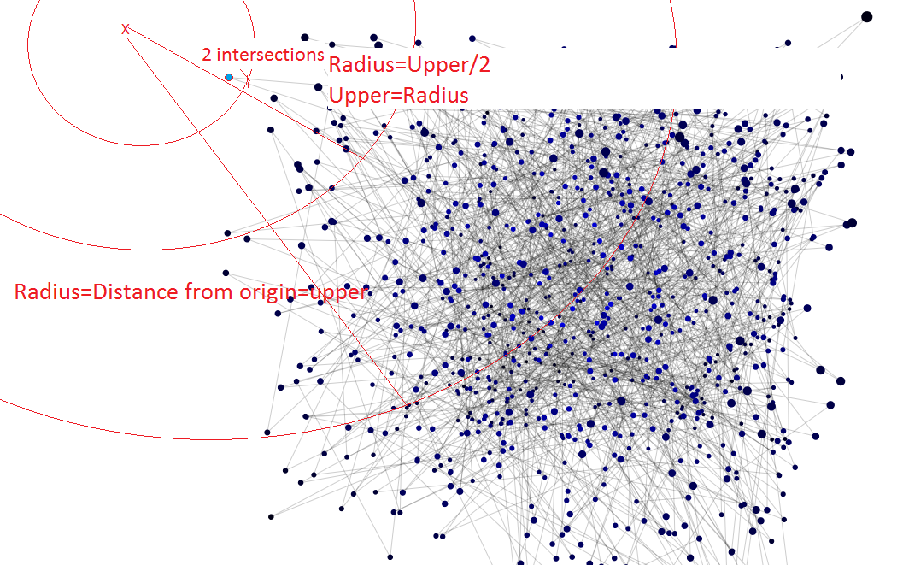

9. Putting everything in place.

*WHY THIS?*

This is one of the most important parts of how our structure would pan out. This is how finally our it would interact with the user, and how well we are able to present different effects, and combine them to give the final look to our network. Also how several different effects can combine together to give a final conclusive adjustment. Also it is very important to get all these things coming together and working. A successful project is the one which has all the small components up and working.

*HOW WOULD I DO IT?*

Again using the same dat.gui libraries I will provide the different available options, of effects such as panning , zooming , colour gradients, hover and click events and interactivity.

All of these will help us decide the best combination for research.

W*HAT WOULD ACTUALLY HAPPEN?*

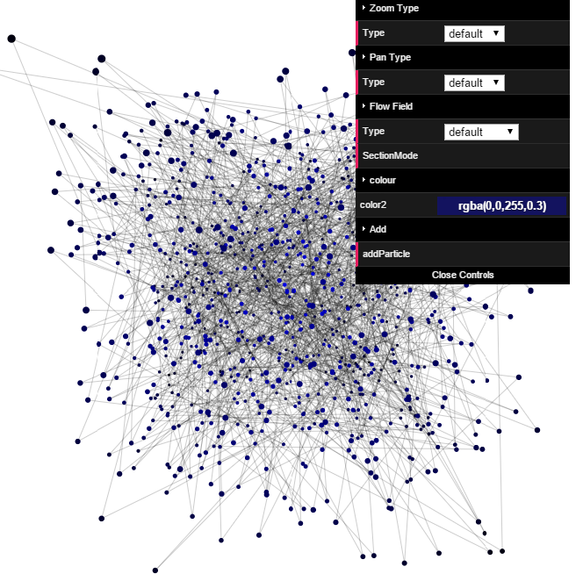The final is expected to look something like this with more detail and would include several effects, as suggested above, and would help us create a good interactive profile.

Additional(s)

It is always better if a few additional things are done during a project, as it always creates a good ending to our works. The proposed additions are as follows-

1.Different layouts

Creating different layouts has always been the in thing. What I propose here is to create some basic layouts and expand the list as we progress. Some common ideas and how I may incorporate them are given as-

2.Assigning variables

It would always be better if we can assign specific particles of interest to a variable so that they may be called upon later on, in a sense be remembered by the computer for the long run. how it would do it follows-

3Particle history:

Generating a database and using it to store every particles history, including creation destruction and previous positions relative to some know particle etc. would obviously help visualising the actual biological use of the graph. If it is not a bioinformatics graph, but a biological network, this is an essential input.

Conclusion

I would like to say that the 7-8 leftover days would make up for work that was left pending and wasn't completed up to the previous deadline and also would give us the freedom to incorporate any interesting idea that might come up during the coding period (like the additional), as it is not just about hanging in there and completing the job, but it is also about giving it your best. As it is said "Promise only what you can deliver, then deliver more than you promise". As the organization recently introduced its new WebGL renderer, using it as my basis would also be an interesting thing and I would like to work upon it. By this I rest my case, and would hope that this leads to the betterment of the Open Source Community as a whole. Also I would love to learn some Biology this summer, and hope it would be great.

Commitments this summer

My examinations for this semester are scheduled to end on the 31st of April, After which I will have my summer vacation till the end of July. I have absolutely no school/college related activities that may consume a considerable chunk of my time and no commitments to a full time job or internship, until this proposal gets accepted. I would love to code most of the time, and *I sleep lesser than I code*. Also I can happily devote *40 (forty) hours every week* into the betterment of the project and would certainly complete the proposed in the given time interval.  
Thanks already.